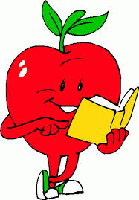
FINAL REVIEW – ENGLISH – GRADE 3
Task 1: Give the correct forms of the words in brackets
1. He (get) ........................... up at 6 o’clock.
2. He (have) .......................... breakfast at 6.30.
3. He (go) ............................. to school at 11.30.
4. I (have) ............................. dinner at 6p.m.
5. I ( like) .............................. pizza and my brother ( like).......................... chicken.
6. My mom (not/like) ................................................... candy.
7. Jenifer ( not/like )..................................................... cakes.
8. .....................she (like)...................................... bananas? Yes, she ......................
9. ........................he (like)..................................... sushi? No, he ...........................
10. I (not/like) ............................................... ........tiger very much.

Task 2: Give the form of the verbs and answer the following questions:
1. ............... she (work)................................. in a store? Yes, she.........................
2. ............... he (work).................................. in a hospital? No, he ........................
3. ............... he (work).................................. in a fire station? Yes, he ...................
4. ................ she ( work)............................... in a school? No, she ..........................
5. .................you (go).................................to HVT school? Yes, I .........................
6. .................you ( study) ........................... grade 2? No, I ..................................
7. .................they (play)............................. football? Yes, they............................
8. .................they (play) .............................basketball? No, they..........................
9. ..................Peter (get) .........................up at 6? Yes, he ..............................
10. .................Mary (make) ............................... the snowman? No, she ..................


Task 3: Give the correct form of the verbs
1. His favourite animal (be)................................ the tiger.
2. His favourite animals (be) ............................... tigers.
3. There (be) ................................... four elephants at the zoo.
4. The lions (eat)................................salad.
5. The lions (eat) ..............................salad at the moment.
6. He (fly) ................................... a kite.
7. He (fly) .................................... a kite now.
8. I (fly) ...................................... a kite at present.
9. What ...................you (do) ...................................now?
10. They (make) ..................................... a snowman now.
11. She (not/do) ..................................... her homework at the moment.
12. I (go) .................................... to school now.
13. What ...................she (wear).................................. today?
14. She (wear) ....................................... a blue dress.
15. I (wear)................................................. a white shirt and blue pants.
16. Look! The car (go)................................. so fast.
17. They (cook) ...........................................lunch in the kitchen.
18. At present, they (travel) .............................................to New York.
19. He (not/work) ............................................................. at the moment.
20. I (not/stay)................................................................... at present.
21. Listen! The bird (sing) ....................................................

Task 4: Give the Comparative form of these adjectives
1. tall ....................................
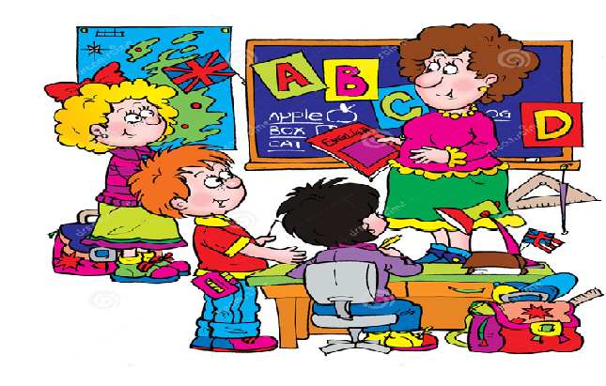
2. short ......................................
3. small ......................................
4. big .........................................
5. cold .......................................
6. hot ........................................
7. long .....................................
8. young ....................................
9. clean .....................................
10. slow .....................................
11. fast .......................................
12. thin ......................................
13. loud .....................................
14. wet .....................................
15. soft ....................................

Task 5: Combine the words into sentences
1. Billy / short/ Rosy.
....................................................................................................................................
2. The cow/ slow/ the horse.
....................................................................................................................................
3. The goose/ loud/ the chicken.
....................................................................................................................................
4. The car/ fast/ the bike.
....................................................................................................................................
5. Jony/ tall/ Joe.
....................................................................................................................................

6. Jim/ thin/ Jack.
....................................................................................................................................
7. My dad/ walk/ at the moment.
....................................................................................................................................
8. The cow/ bigger/ the bear.
....................................................................................................................................
9. Bikes / slow/ cars.
....................................................................................................................................
10. Mary/ go to school/ 6 o’clock.
....................................................................................................................................
11. I/ study/ English/ now.
....................................................................................................................................
12. He/ do his homework/ at the moment.
....................................................................................................................................
13. She/ not like to watch movies.
....................................................................................................................................
14. They/ not like eating chicken.
....................................................................................................................................
15. I / wear / a T-shirt and shorts/ at present.
....................................................................................................................................

Task 6: Write sentences with Comparative
1. The horse (fast) ....................................................................................the goat.
2. The girl (weak)......................................................................................the boy.
3. The man (tall)........................................................................................ the woman.
4. The sheep (small)...................................................................................the cow.
5. The elephants ( big).................................................................................the donkeys.
6. The turtles (slow) ....................................................................................the rabbits.

Task 7: Answer the questions
1. What are you wearing?
(wear)............................................................................................................................
2. What are you doing?
(dance)..........................................................................................................................
3. When do you brush your teeth?
(10p.m)..........................................................................................................................
4. When you go to school?
(in the morning)............................................................................................................
5. What is he doing?
(watch TV)....................................................................................................................
6. What are they doing?
(eat dinner)....................................................................................................................
7. What is he doing now?
(take photos).................................................................................................................
8. Does she like playing basketball?
No, .............................................................................................................................
9. Does he study English at VUS?
Yes, ..............................................................................................................................
10. Are they talking on the phone?
Yes, ..............................................................................................................................
11. Are they sleeping at the moment?
No, ................................................................................................................................

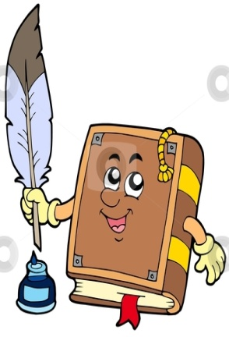
Task 8: Give the past forms of “be” these sentences
1. On Wednesday, it (be).................................... our school play.
2. The children (be/not).......................................in the classroom.
3. They (be) ...................................... in the schoolyard.
4. Our mom and dad (be) ..................................... there, too.
5. Our teacher (not/be) .................................sad.
6. Our teachers (not/be)..................................sad.
7. All the children (be) ................................... very happy.
8. I (be) .....................................hot yesterday.
9. You (be) .....................................good.
10. He (be) .....................................bad.
11. The street (be) ....................................dry.
12. .................. he (be) ..........................here yesterday? Yes, he ................................
13. ......................she (be) ........................school on Saturday? No, she ......................
14. ......................they (be) ...................... at home last night? Yes, they .....................
15. .......................you (be) ......................at cinema last Sunday? No, .........................

-----------------------

